Rural Medicaid Toolkit
The reconciliation budget bill will slash $800 billion in funding for Medicaid and the Affordable Care Act, causing 15 million Americans to lose their health coverage and become uninsured, thus destabilizing rural healthcare infrastructure. NRHA has numerous ways for you to get involved and make your voice heard:
- Medicaid Cuts and Rural Impact One Pager
- Rural Medicaid Talking Points
- Template Letter to Senators
- Template Op-Ed
- Advocacy Campaign: Urge Congress Against Cuts to Medicaid
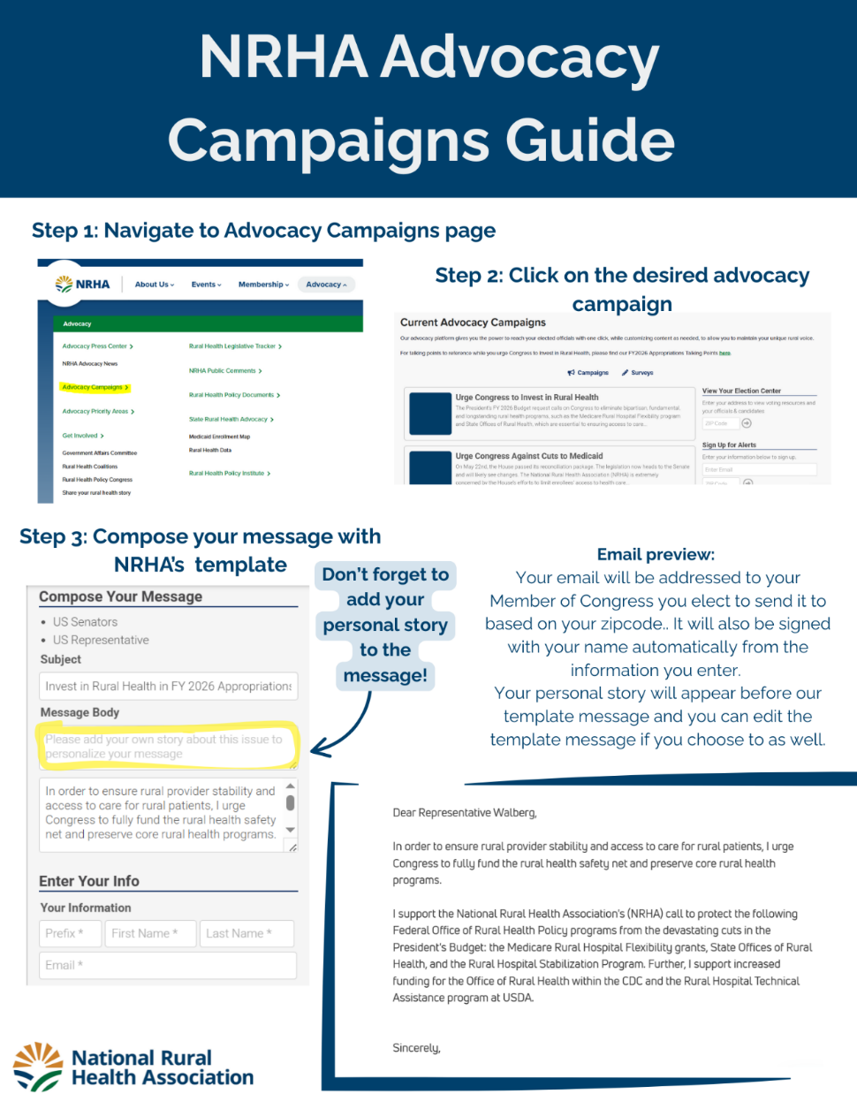

Template Letter to Senators
June X, 2025

Senator Name
Office Location
Washington, D.C. 20510

Dear Senator Name,

Following the passage of the House reconciliation bill, [Your organization] is writing with grave concerns over certain provisions regarding the Medicaid Program. We urge you to vote NO on healthcare cuts in the reconciliation package.

Medicaid is essential to our rural hospitals, clinics, providers, and patients. [X] percent of rural residents in [State] are enrolled in Medicaid. The proposed Medicaid cuts would force [State] families to face higher out-of-pocket expenses, leading many to delay or forgo necessary treatments. This burden would worsen health outcomes, especially for those managing chronic conditions like diabetes, heart disease, and cancer. These are parents, children, and working adults who would no longer be able to obtain needed health care due to it being unaffordable. These are our neighbors, many of whom have chronic diseases that have to be regularly managed. Without coverage, many would go without care and end up in the emergency room or inpatient facility, resulting in uncompensated care that they will not be able to pay.

In [State], [Number] rural hospitals have shut their doors or stopped inpatient services since 2010. When a rural hospital closes, not only does the community lose access to vital health care, but a major employer and community lynchpin ends, affecting the economic health of the larger community. Cuts to Medicaid introduce threats to the rural health care safety net. Since rural hospitals disproportionately depend on reimbursement from public payers, including Medicaid, Medicare, and the Marketplaces, any reductions to Medicaid would force many facilities to reduce or eliminate essential services, delay much-needed facility upgrades, or close their doors entirely.

[Add any specific information about rural hospitals and other providers in your state and how Medicaid cuts would impact them.]

We are specifically concerned about proposals to:
- Freeze current rates states’ provider taxes in effect as of the date of enactment of this legislation and prohibits the establishment of new provider taxes.
- Prohibit future increases or use of provider taxes, which will further strain [State]’s Medicaid budget, forcing our state to reduce coverage, eliminate optional benefits, or reduce provider payments.
- Limit state-directed payments, which will threaten rural providers who rely on these funds to sustain key services and make up for inadequately low reimbursement rates. Providers currently participating in Medicaid may begin to drop out due to lower reimbursement from Medicaid MCOs, ultimately decreasing access to care, particularly for rural Medicaid enrollees.
- Establish a minimum work requirement for certain adults enrolled in Medicaid as a condition of coverage. Rural residents are more likely to be low-wage workers, more likely to be unemployed, and have fewer job options than urban counterparts, making rural Medicaid enrollees more susceptible to losing coverage under work requirement policies. As a result, work requirements add significant administrative burdens that rural residents may struggle to meet, risking coverage loss due to paperwork issues rather than eligibility.
- Limit Medicaid coverage for qualified medical expenses to one month prior to the application for coverage process will limit rural constituents’ access to healthcare, increase their risk of medical debt, and create more uncompensated care burden for rural hospitals and providers.
- Increase Medicaid eligibility redeterminations from 12 months to 6 months for expansion population adults. Medicaid and CHIP enrollment declines have been associated with an individual’s inability to maintain frequent renewal processes and periodic eligibility checks.

Additionally, changes to the ACA Marketplaces will increase premiums and make it more difficult for rural residents to enroll in and maintain coverage. The combined effect of Medicaid and Marketplace changes will lead to [Number] constituents losing health insurance coverage. Rural residents are more likely to be self-employed and reliant on small business and individual plans for coverage than urban residents. The changes proposed in the reconciliation bill, coupled with the failure to extend the enhanced premium tax credits and Medicaid cuts, will mean disastrous coverage losses and decreased access to care for rural residents.

[Your organization] requests an opportunity to meet with your office virtually to discuss this important issue. Please contact [name] at [email and/or phone number] to schedule a time to discuss further.

Sincerely,

[Insert e-signature]

[Name]
[Title]
[Organization]

Template Op-Ed
Title: Proposed Cuts to Medicaid Threaten the Health and Survival of Rural [STATE]
In rural [STATE], Medicaid is not just a safety net, it is the backbone of our health care system. As Congress debates proposals that would impose drastic cuts and restrictions on the Medicaid program, rural communities like ours stand to lose the most.
The House-passed reconciliation bill would reduce federal Medicaid spending by $793 billion over the next decade, a 12% cut nationally. In [STATE], that could translate to a [X]% reduction in federal Medicaid funds and a projected loss of coverage for [X] residents. In many rural areas, Medicaid and other public payers are significant, if not the largest, payers for hospitals, clinics, and providers.
Cuts to the Medicaid program, whether by limiting funding mechanisms, adding eligibility barriers, or reducing coverage protections, would devastate rural patients and providers alike. Medicaid helps keep rural hospitals open. Yet in the midst of discussions to cut the program, almost half of all rural hospitals in the United States already operate at a loss, and 193 have closed or stopped providing inpatient care since 2010. These closures don’t just eliminate access to care; they eliminate jobs, weaken local economies, and leave entire regions without emergency services.
The current proposals under consideration in Congress will make the situation worse for rural communities. These include:
- Freezing state provider taxes, which make up roughly 17% of states’ share of Medicaid funding. Without the ability to increase or introduce new provider taxes, states will be forced to cut services or reduce Medicaid reimbursements, especially harmful for rural providers that already operate on razor-thin margins.
- Capping state-directed payments, which states use to help rural providers stay afloat in the face of chronically low Medicaid reimbursement rates. Restricting this funding stream puts essential services, like obstetrics, behavioral health, and emergency care, at risk.
- Imposing Medicaid work requirements, which disproportionately harm rural enrollees. Rural residents are more likely to face transportation barriers, seasonal employment, and limited broadband access, making it harder to comply with red tape and easier to lose coverage due to paperwork, not eligibility.
- Reducing retroactive eligibility and increasing the frequency of eligibility redeterminations, which would result in more uninsured patients showing up at rural clinics and hospitals, and more uncompensated care that providers cannot absorb.
[Insert local example: “Here in [Town/County], our [insert rural provider type] relies on Medicaid to care for nearly [X]% of our patients. If these cuts move forward, services will be reduced, and patients will be forced to travel hours for care, if they can access it at all.”]
Medicaid works for rural [STATE]. It ensures that veterans can access their medications, children get care, working parents can manage chronic conditions, older adults can remain in their homes, and that hospitals can keep their doors open.
Medicaid is more than a policy. It is a promise that no matter where you live, you deserve access to care. For rural [STATE], that promise is now in jeopardy. I urge [insert name of U.S. Senator(s)/ Representative(s)] to reject proposals that gut Medicaid’s funding and access. Instead, protect and strengthen the program that sustains rural health and economy.

Corallo, B., Garfield, R., Tolbert, J., & Rudowitz, R. (2021, 14 December). Medicaid Enrollment Churn and Implications for Continuous Coverage Policies. https://www.kff.org/medicaid/issue-brief/medicaid-enrollment-churn-and-implications-for-continuous-coverage-policies/.
Kaiser Family Foundation. (2024, May 22). Allocating CBO’s estimates of federal Medicaid spending reductions and enrollment loss across the states. KFF. https://www.kff.org/medicaid/issue-brief/allocating-cbos-estimates-of-federal-medicaid-spending-reductions-and-enrollment-loss-across-the-states/
Kaiser Family Foundation. (2025, Feb. 19). Key Facts About Hospitals. https://www.kff.org/key-facts-about-hospitals/?entry=rural-hospitals-rural-discharges-by-payer
Cuello, L. (2025, February 4). Medicaid provider taxes: A critical source of Medicaid funding for states. Georgetown University Center for Children and Families. https://ccf.georgetown.edu/2025/02/04/medicaid-provider-taxes-a-critical-source-of-medicaid-funding-for-states/

